Thesis Topic Evaluation: Computational Efficiency of XAI in Lightweight Plant Disease Detection

This document provides a comprehensive evaluation, structured research plan, and methodological analysis of the proposed thesis topic.

1. Topic Suitability & Academic Merit
The proposed topic—"Impact of explainability models on the computational efficiency of lightweight models in plant disease detection" (using LIME, Grad-CAM, PDP, and SHAP)—is highly relevant, timely, and academically strong. It addresses a critical bottleneck in the deployment of AI in agriculture: the conflict between the need for trust (explainability) and the constraints of edge deployment (computational efficiency).

Why This is a Strong Thesis Topic:
- Real-World Constraint: Plant disease detection is most useful when deployed on-field (e.g., via a smartphone app or edge device on a drone/tractor). These devices have severe memory, processing, and battery constraints.
- The XAI Bottleneck: While lightweight models (MobileNet, ShuffleNet) are optimized for milliseconds-level inference, many post-hoc XAI methods (like LIME or KernelSHAP) require thousands of forward/backward passes, taking seconds or minutes per image. This completely negates the benefit of a "lightweight" model.
- Literature Gap: Most XAI literature focuses on the interpretability quality (faithfulness, localization accuracy) rather than the computational trade-offs on edge architectures.

2. Deep-Dive into the XAI Methods
For image-based plant disease detection, the selected explainability models exhibit vastly different mathematical formulations and computational signatures:
XAI Method | Category | Computational Complexity | Suitability for Images / Plant Disease
Grad-CAM | Gradient-based (Backpropagation) | Very Low (1 forward + 1 backward pass) | Excellent. Highly visual, shows which parts of the leaf (spots, veins) the CNN focused on. Very fast.
LIME | Perturbation-based (Surrogate) | High (Needs $N$ perturbations/forward passes, e.g., $N \ge 1000$) | Good visually, poor computationally. Divides the leaf into superpixels and turns them on/off, requiring a large number of model runs.
SHAP | Game Theory (Shapley Values) | Extremely High (KernelSHAP) / Medium (DeepSHAP / PartitionSHAP) | High quality, but resource-intensive. KernelSHAP is too slow for real-time edge use. DeepSHAP (gradient-based approximation) is faster but memory-heavy.
Partial Dependence Plot (PDP) | Feature Marginalization | Atypical for raw images (High complexity if adapted) | Methodological Challenge. PDP is designed for tabular data (e.g., plotting the effect of 1-2 features on the output). For image pixels, PDP is practically impossible without reducing dimensions or using superpixels.
WARNING
Methodological Challenge (PDP): Applying PDP to raw image pixels is not standard because of the high dimensionality ($224 \times 224 \times 3 \approx 150,000$ features). To use PDP, you will need to apply it to high-level extracted features (e.g., leaf color ratio, spot count) or global image statistics rather than raw pixels, or substitute it with a more image-friendly global XAI method like Saliency Maps or Integrated Gradients.

3. Benchmarking Framework
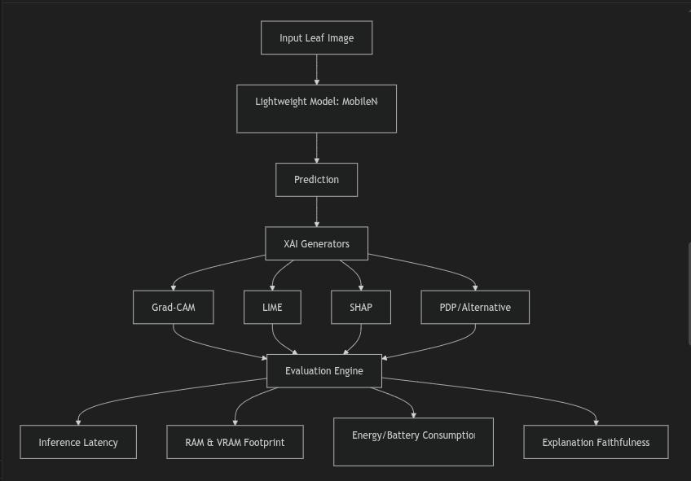
To write a rigorous thesis, you should establish a benchmarking framework comparing the explainability models across these dimensions:

Proposed Key Metrics to Measure:
- Inference Latency vs. Explanation Latency: Time to run model.predict() vs. time to generate the explanation map.
- Memory Footprint (Peak RAM/VRAM): Crucial for edge systems where RAM is capped (e.g., Raspberry Pi or mobile devices).
- Energy Consumption (Joules/mWh): Measured using hardware profilers or software estimators (like CodeCarbon) to determine battery drain on mobile devices.
- Fidelity/Accuracy Trade-off: Do faster XAI models give worse/less reliable explanations?

4. Suggested Implementation Roadmap
To get this research running in your workspace (explainability_impact), we can structure the codebase as follows:
explainability_impact/
│
├── data/ # Sample images from PlantVillage dataset
├── models/ # Trained lightweight models (MobileNetV3, ShuffleNetV2)
├── src/
│ ├── __init__.py
│ ├── explainers.py # Implementations of Grad-CAM, LIME, SHAP, PDP
│ ├── benchmark.py # Latency, memory, and energy profiling logic
│ └── utils.py # Image preprocessing and loading helpers
├── notebooks/ # Exploratory notebooks for visualizing explanations
└── main.py # CLI interface to run the full benchmark suite

5. Key Questions for Refining the Scope
To tailor this research to your specific academic goals, consider the following questions:
- Target Hardware: Will you benchmark this purely on a simulation environment (e.g., your local CPU/GPU mimicking edge constraints), or do you plan to deploy and measure on physical edge devices (e.g., Raspberry Pi, Jetson Nano, or Android/iOS emulator)?
- Dataset choice: Is the PlantVillage dataset the primary target, or are you looking at a custom local agricultural dataset?
- Clarifying PDP: How do you envision implementing PDP for image inputs? Would you prefer to substitute it with a gradient/perturbation method more suited for images, or apply it to structured tabular features derived from the images?

